Why is git around?

* Version control system
* Easily recover files
* Who introduced an issue and when?
* Rollback to previously working state.

History of VCS

* Local VCS: db to keep control or track of files with time stamps. Pros are that we can keep tracks of files and rollback at any stable position.

Drawback that local files are maintained so if laptop or computer is destroyed then all data is lost.

* Centralized VCS:
* 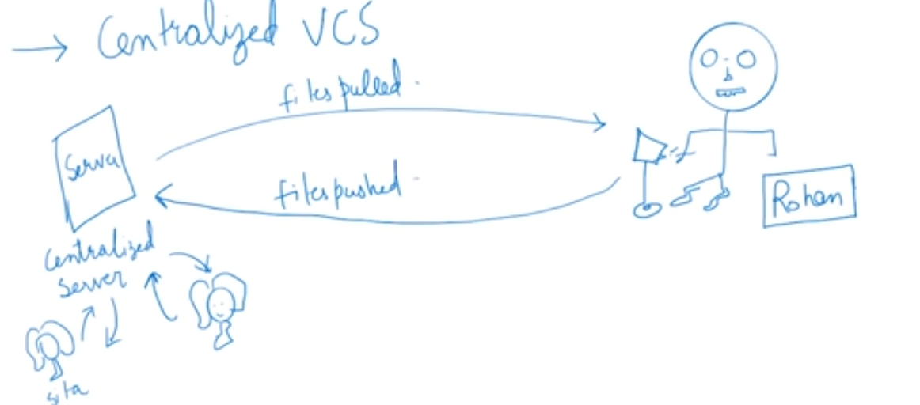
* 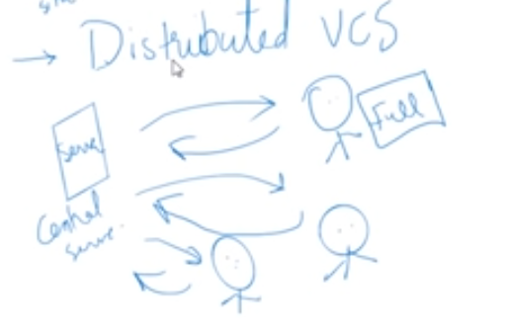

Note: git is distributed VCS.

How was git created?

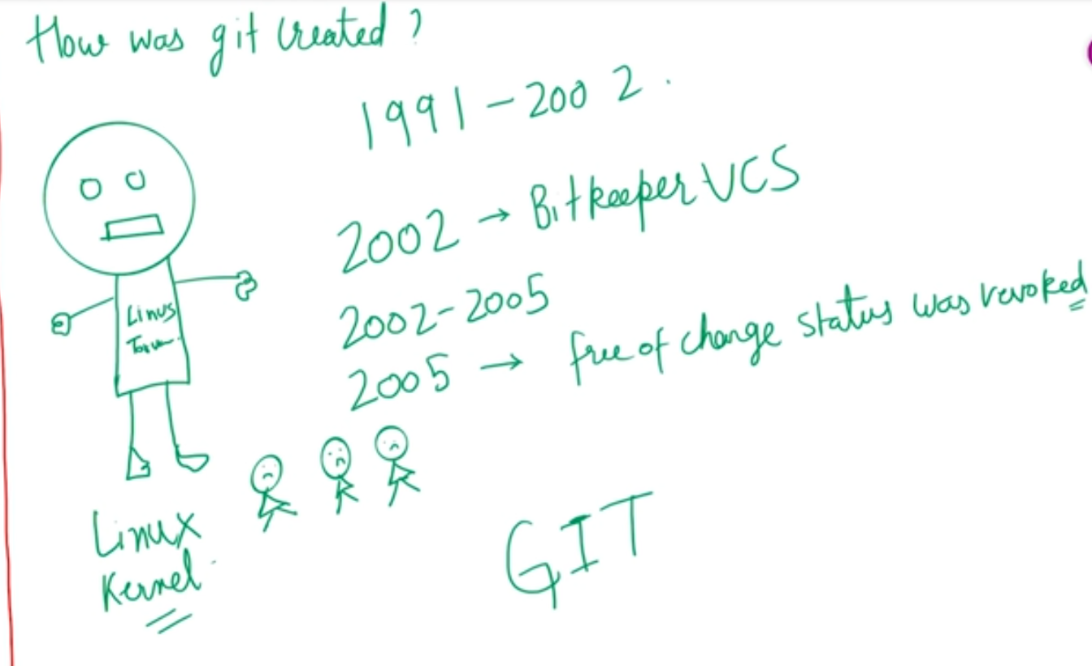

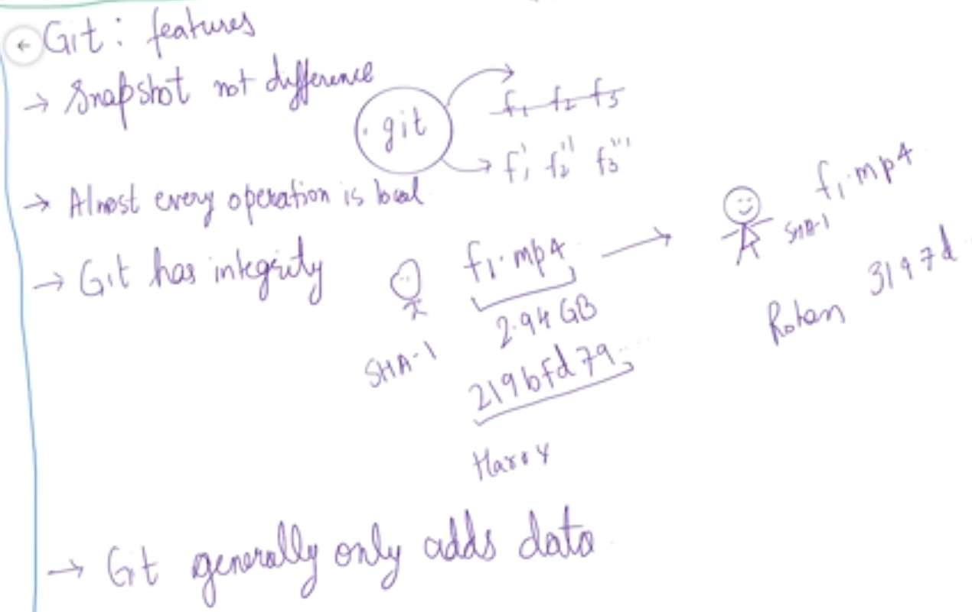

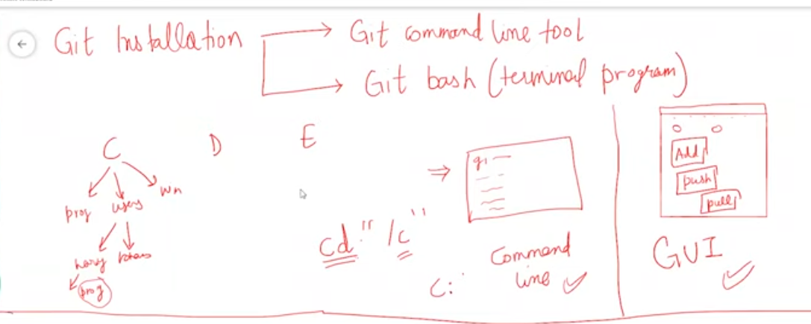

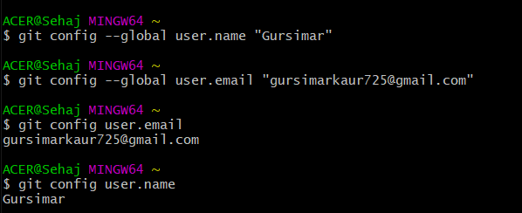

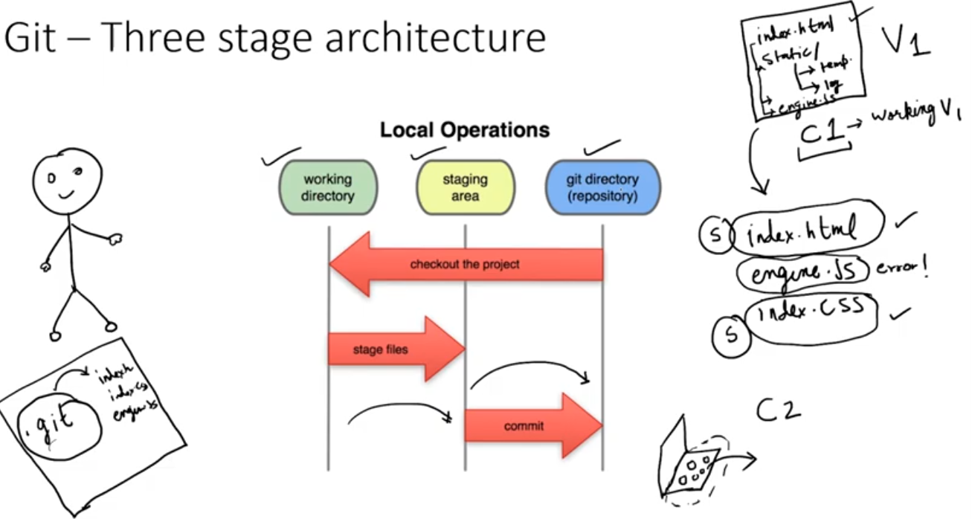

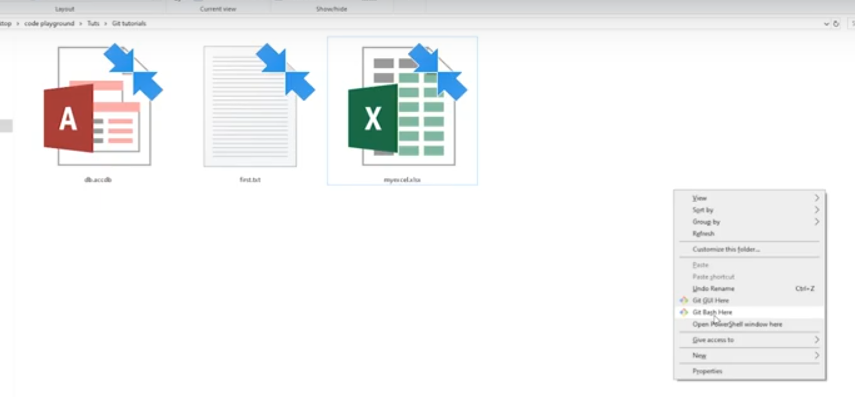

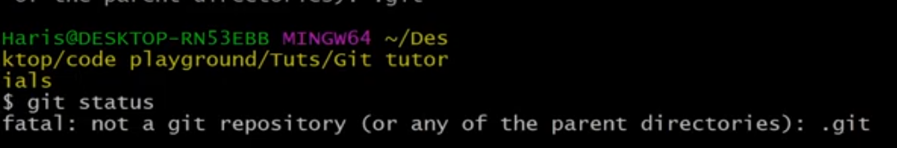

NOTE: git status is basic command and it is necessary to check the git status of the folder to verify whether it is already a git repository or not.

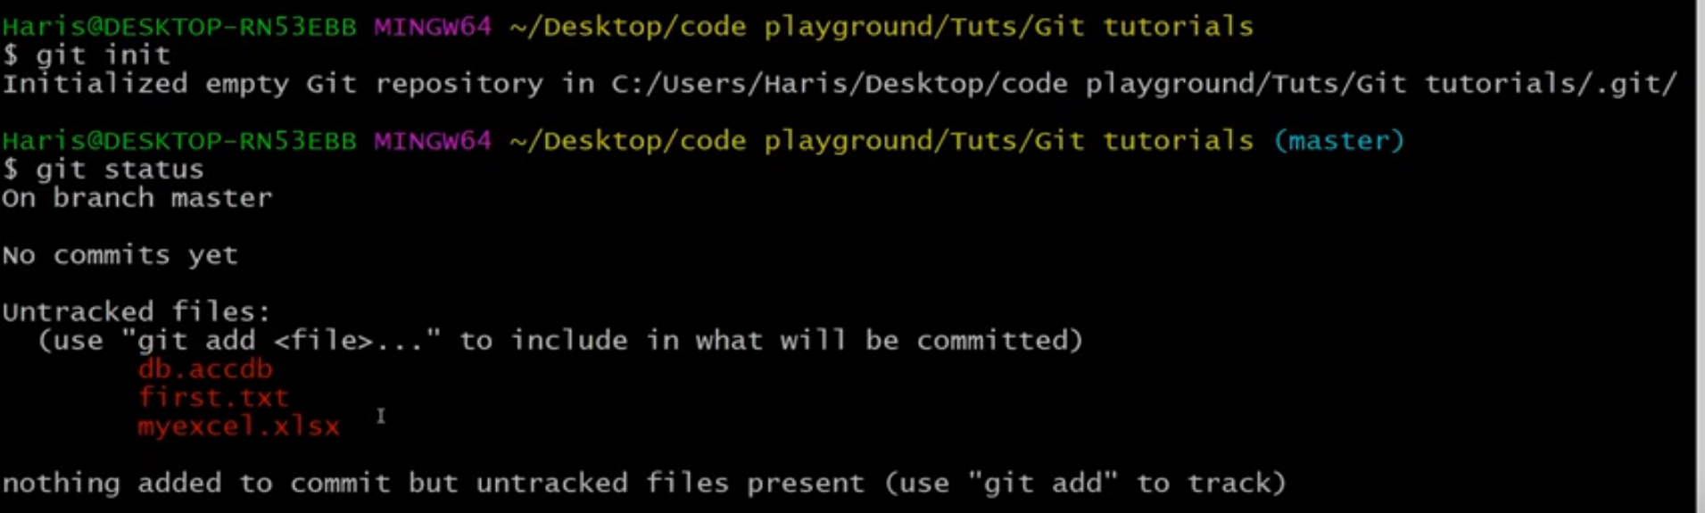

NOTE: first we have to initialize a git repository and it will create it but will not commit any file that are already within that folder to be committed.

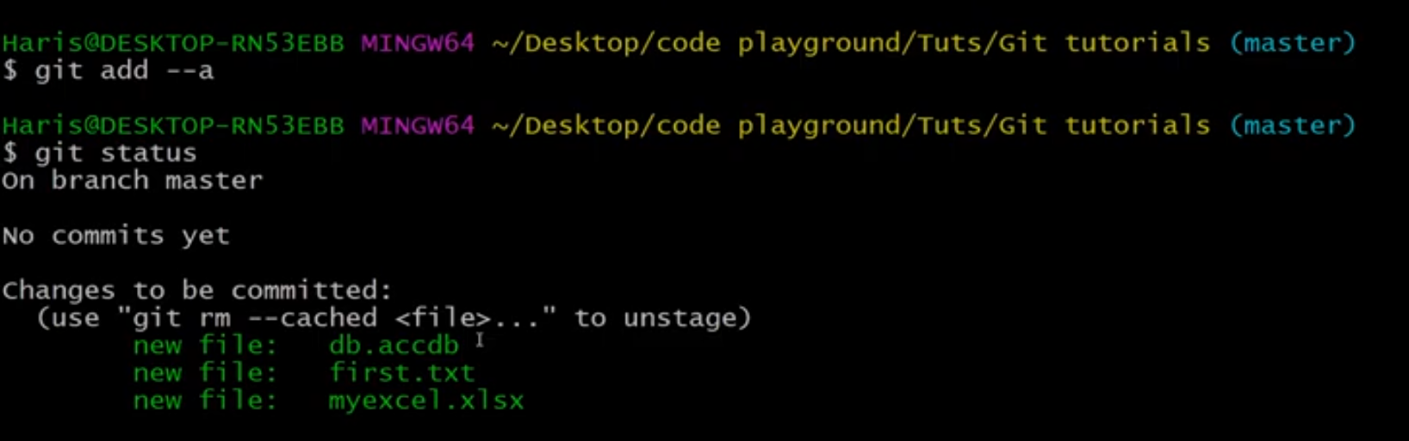

NOTE: we can commit the files using the commands “git add --a”. here a means all files within the folder.

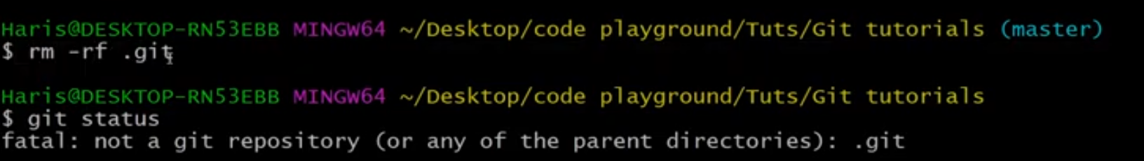

NOTE: deleting the .git repository using rm command as shown above.

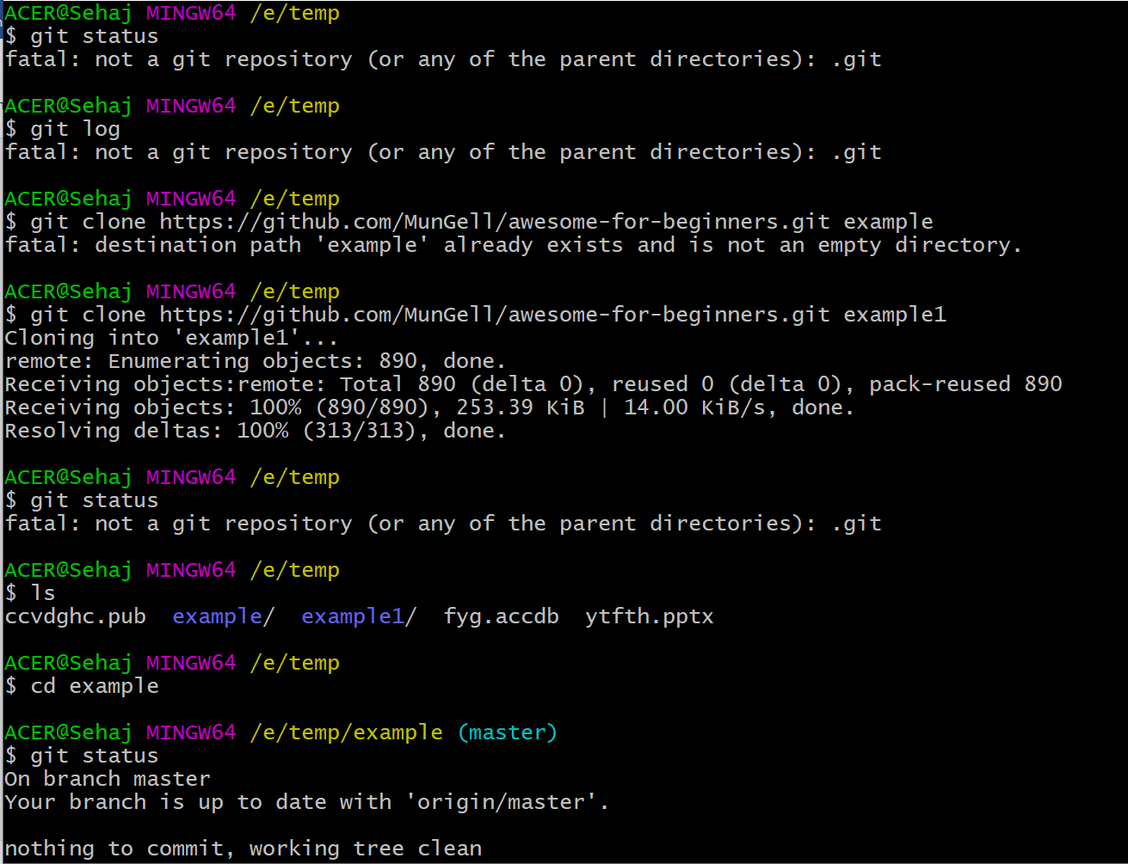

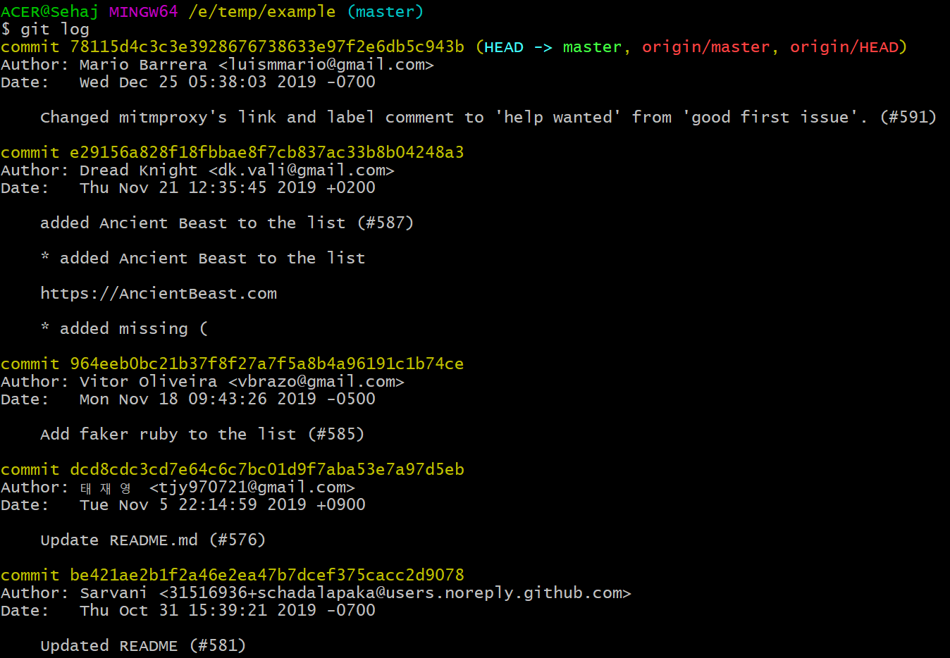

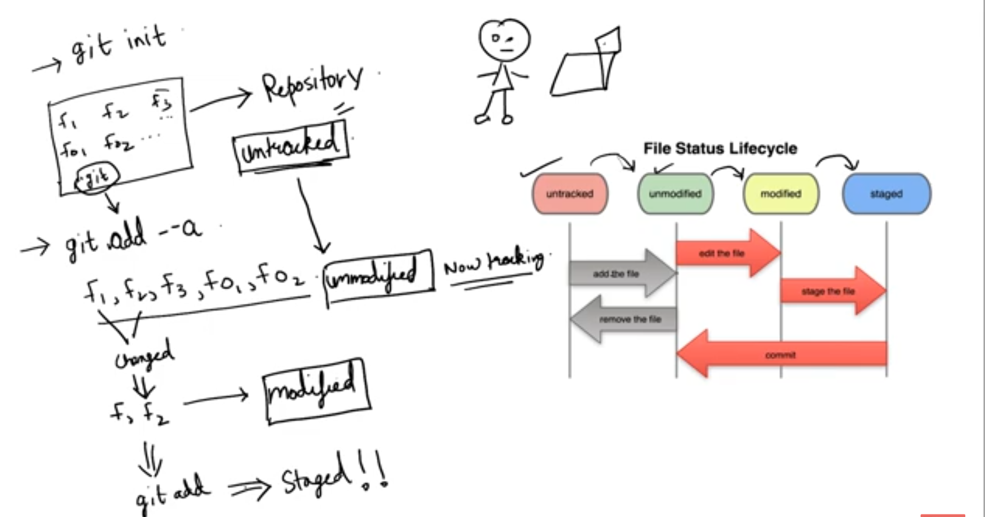

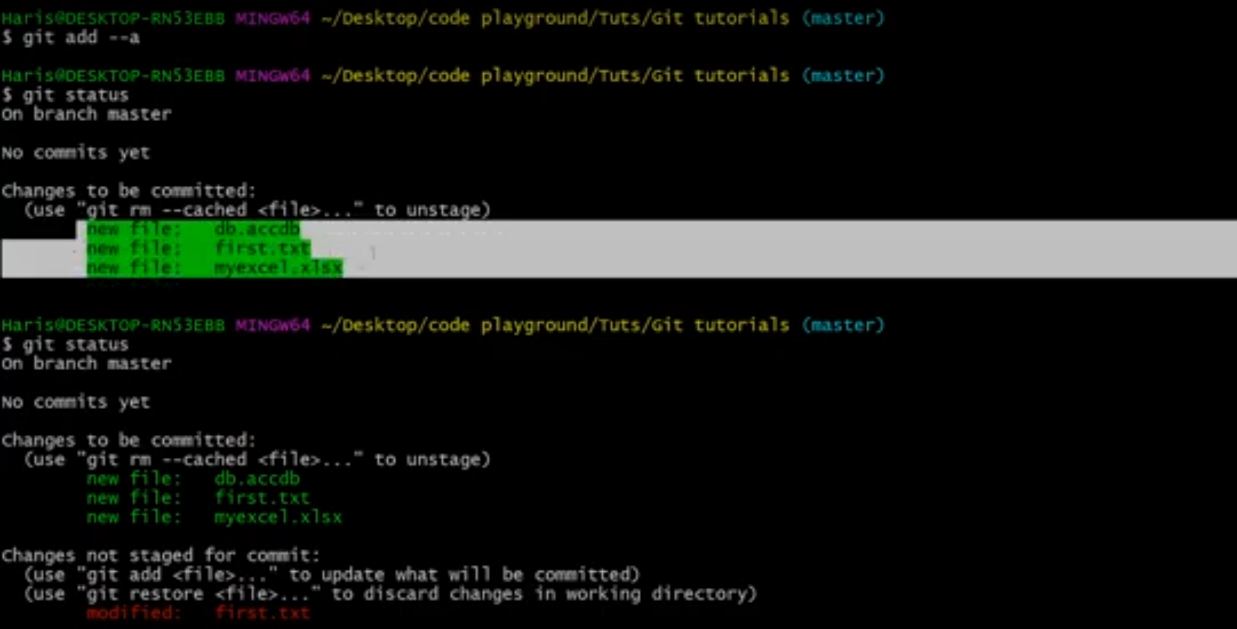

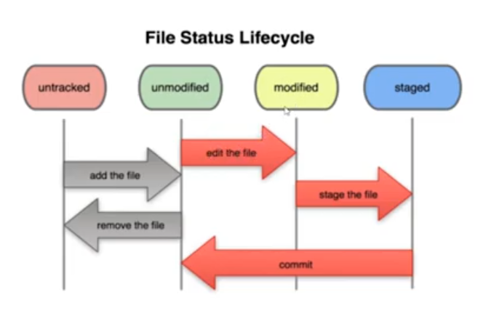

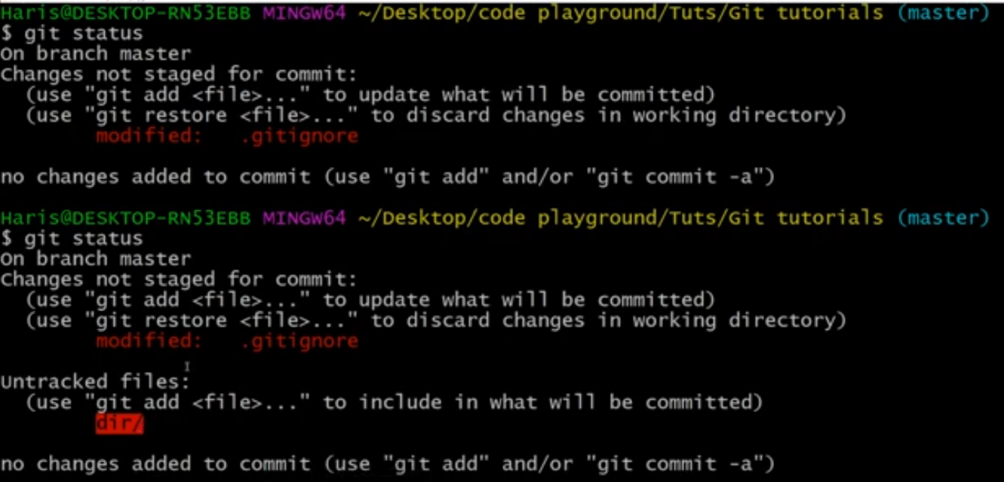

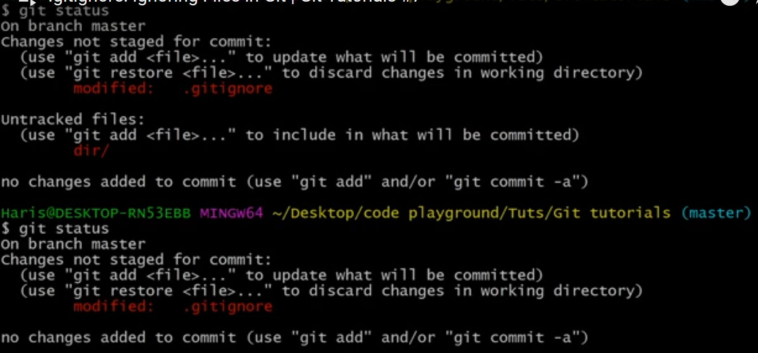

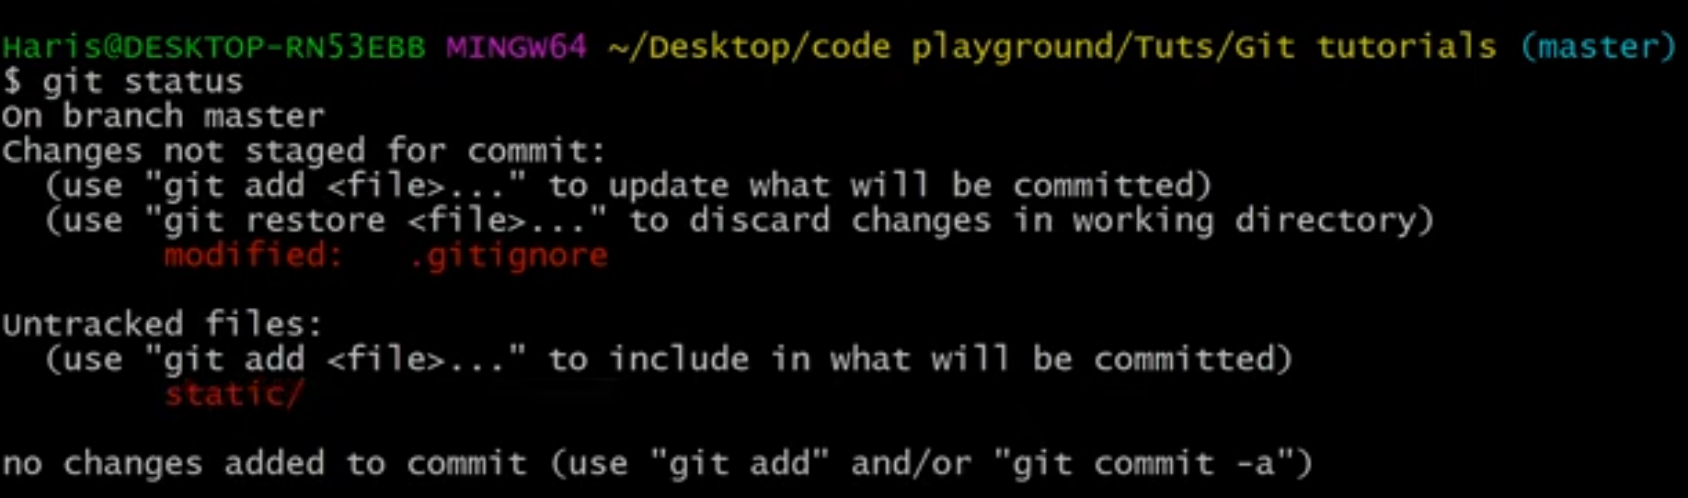

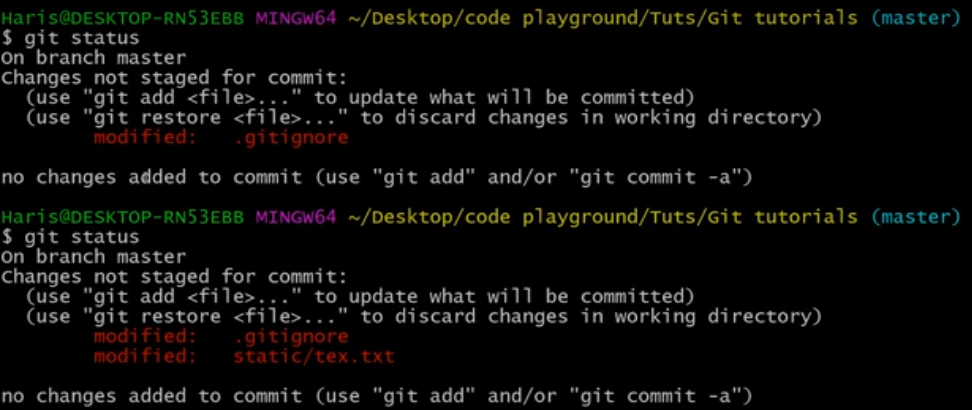

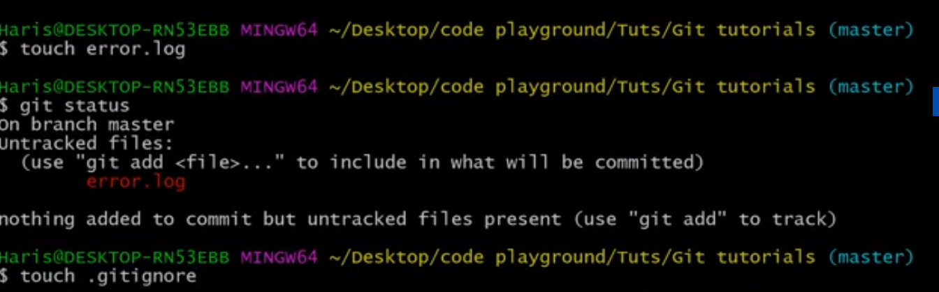

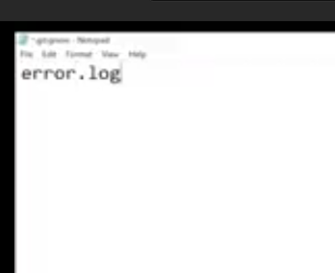

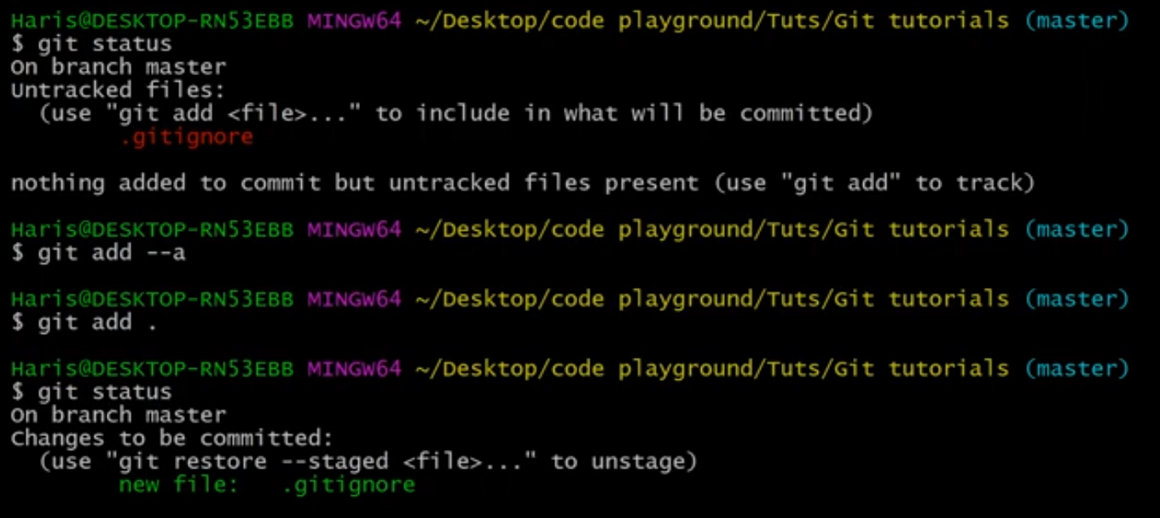

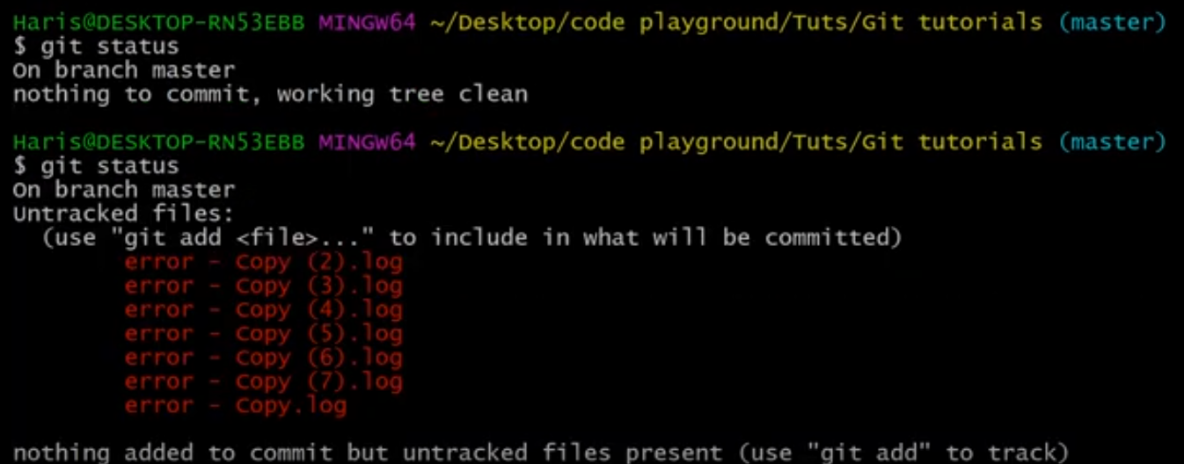

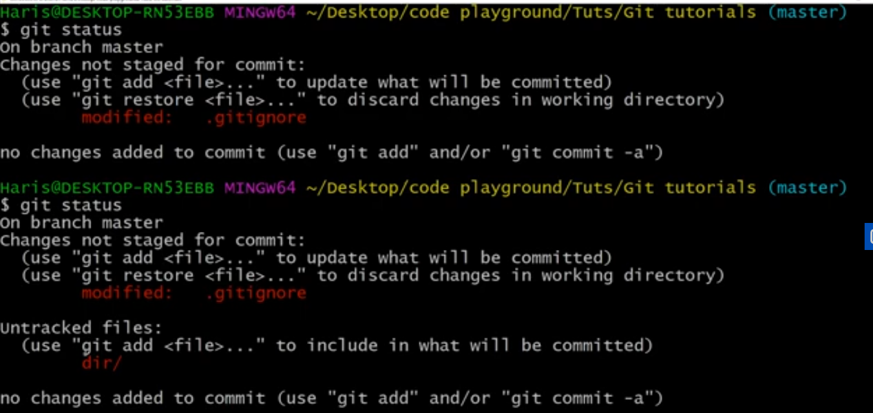

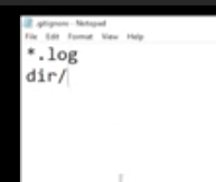

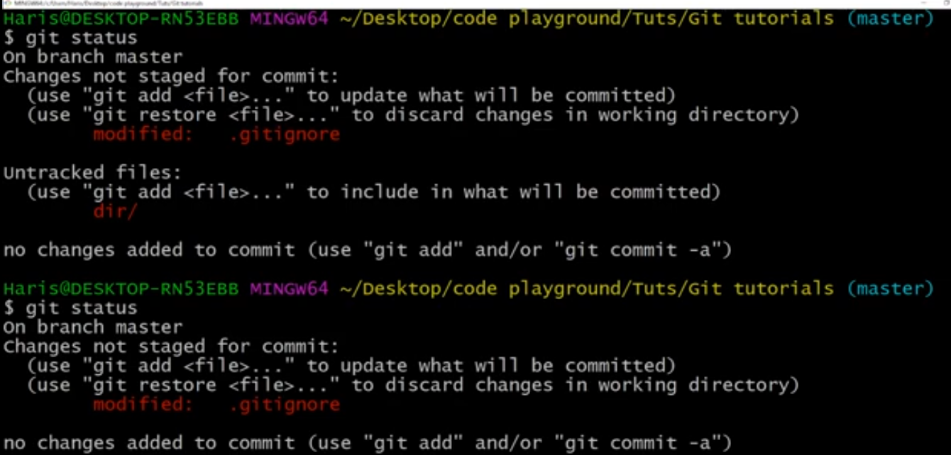

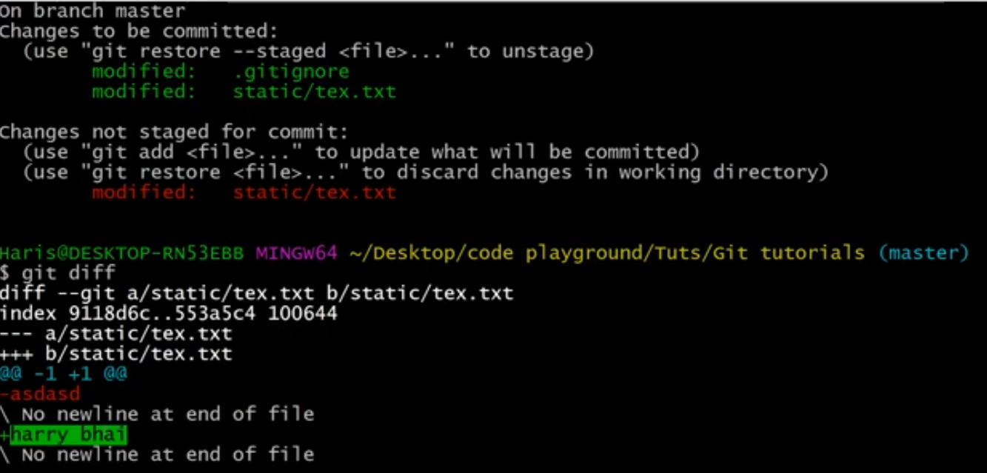

NOTE: git diff compares working directory with staging area.

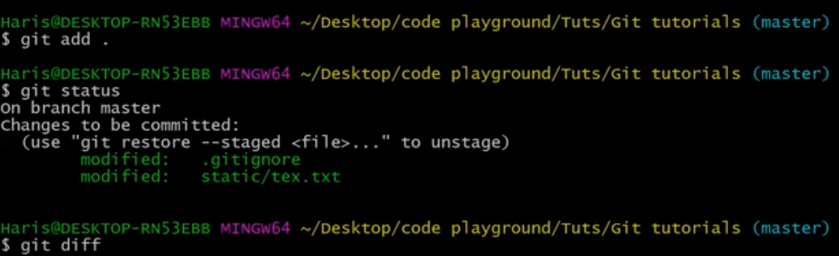

NOTE: no difference as both stanging and working area are same.

WE CAN ALSO COMPARE PREVIOUS COMMIT WITH THE RECENT COMMIT USING THE FOLLOWING COMMAND.

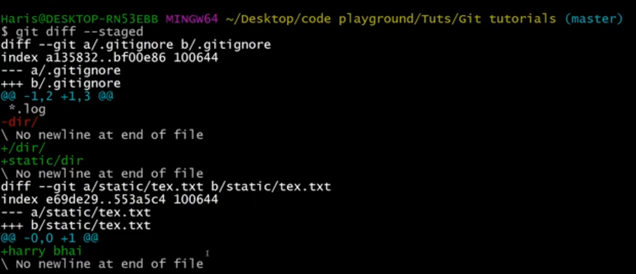

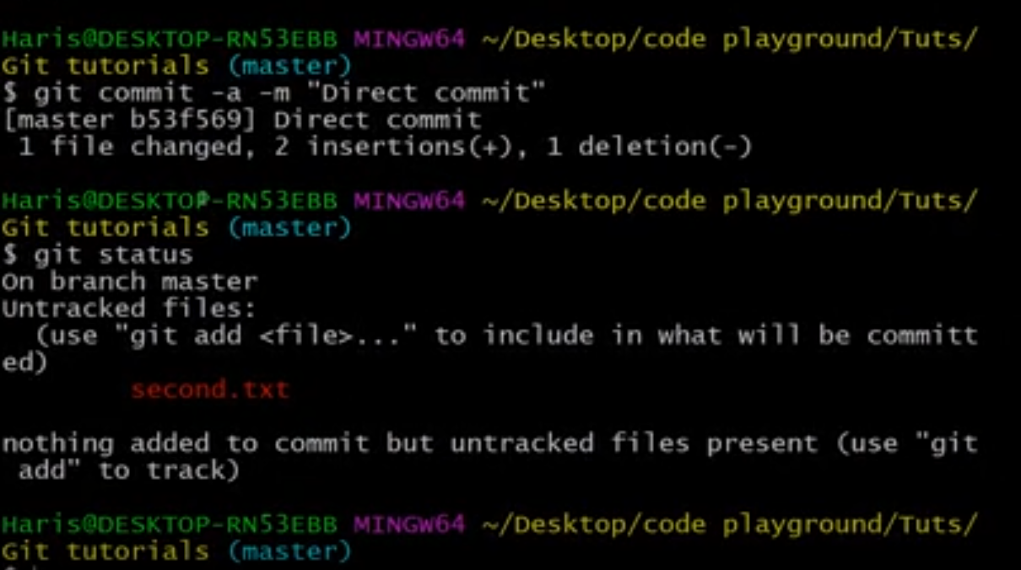

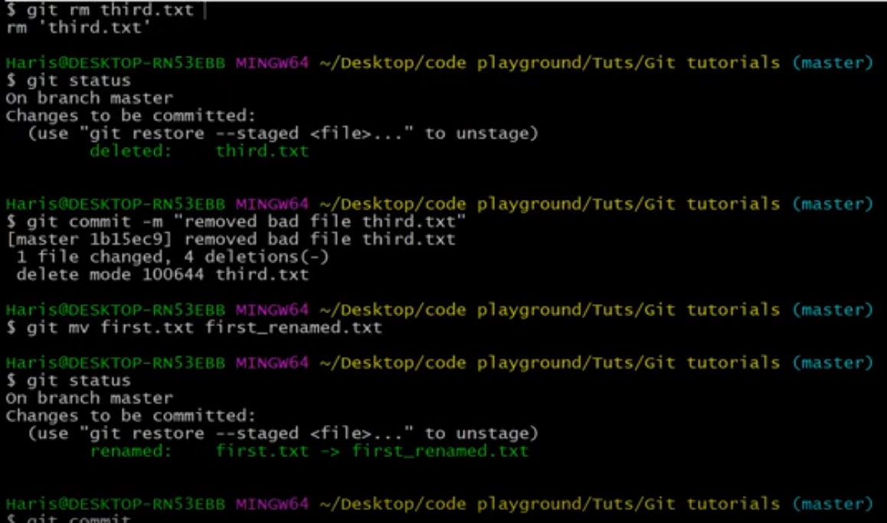

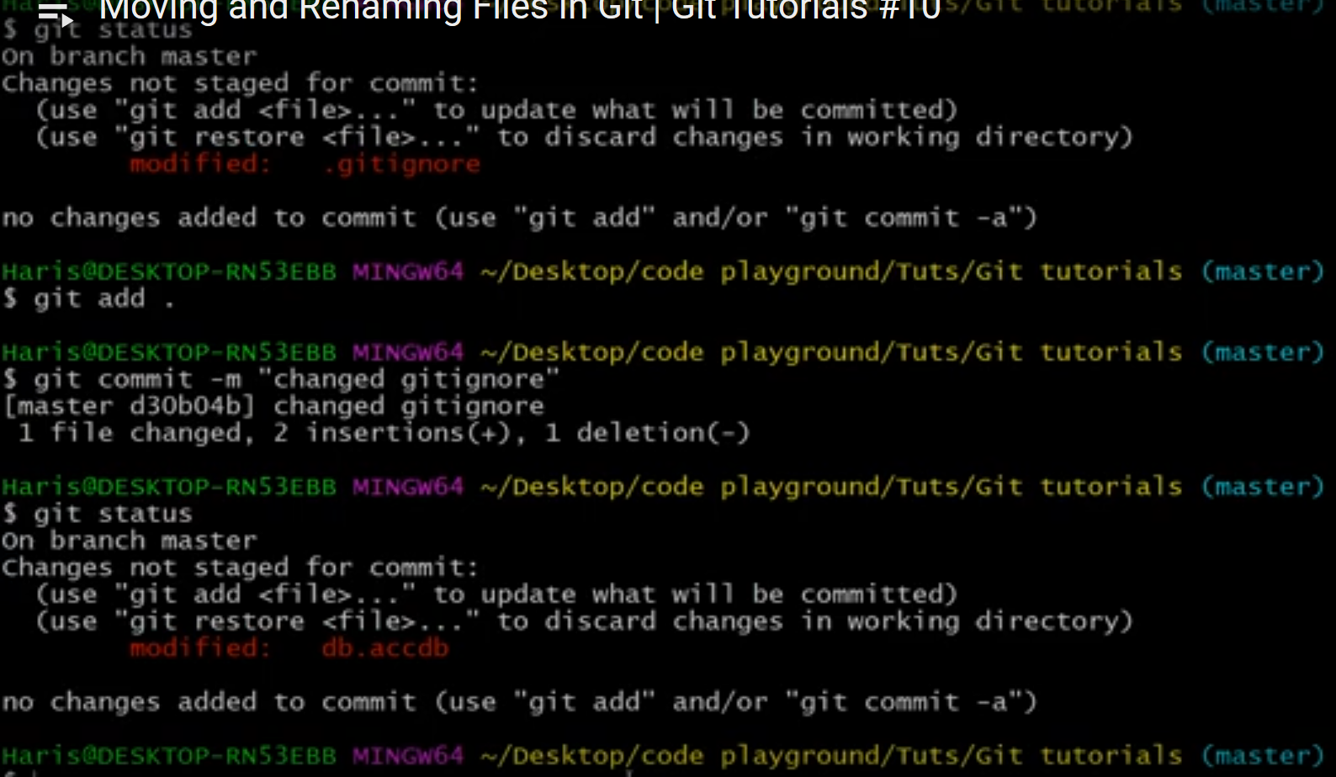

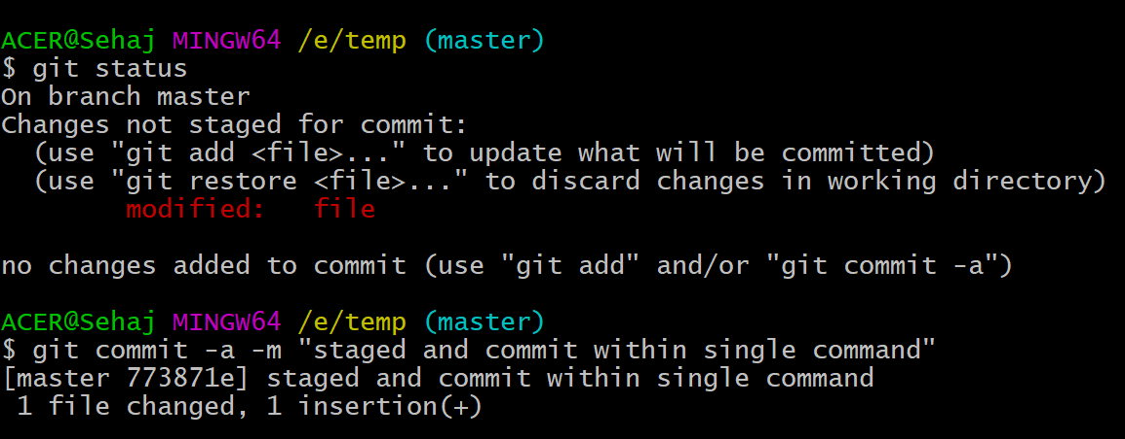

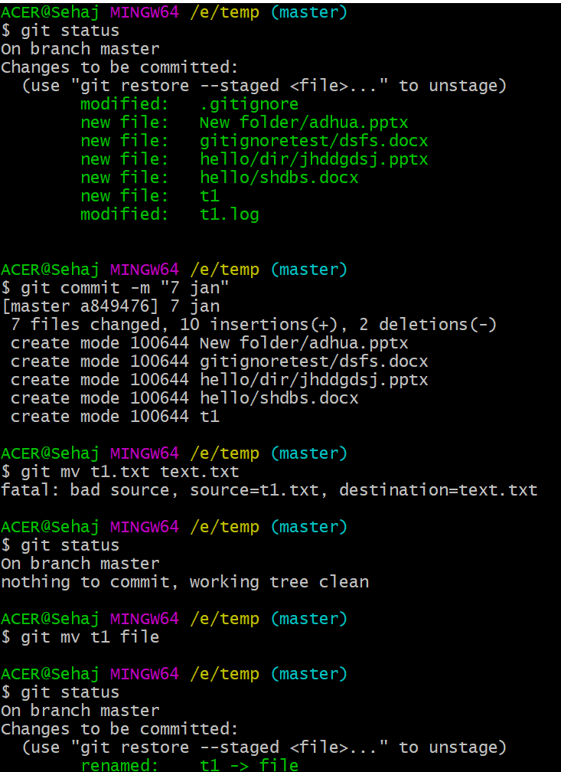

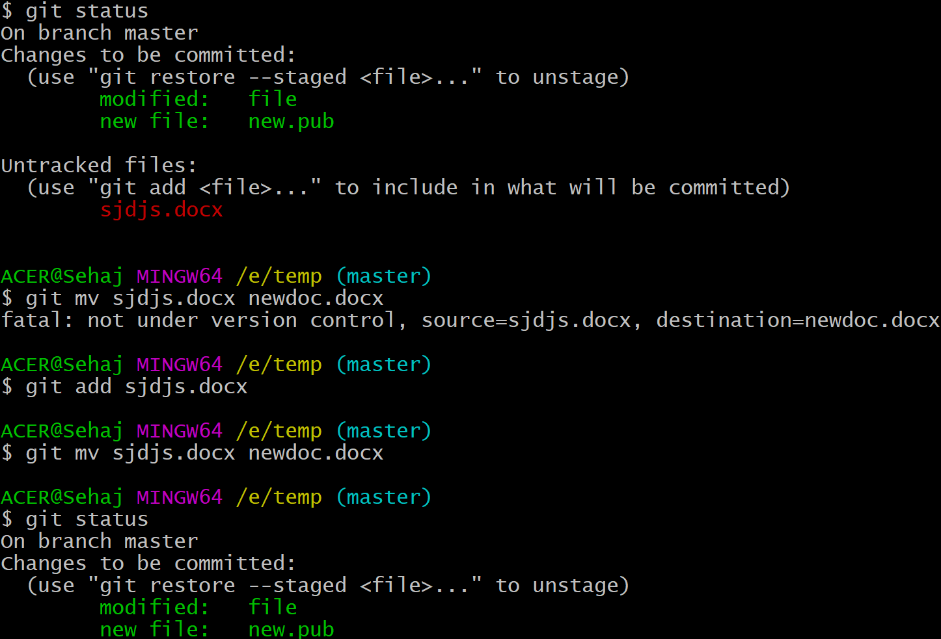

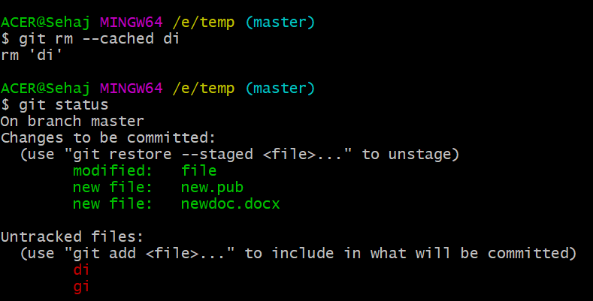

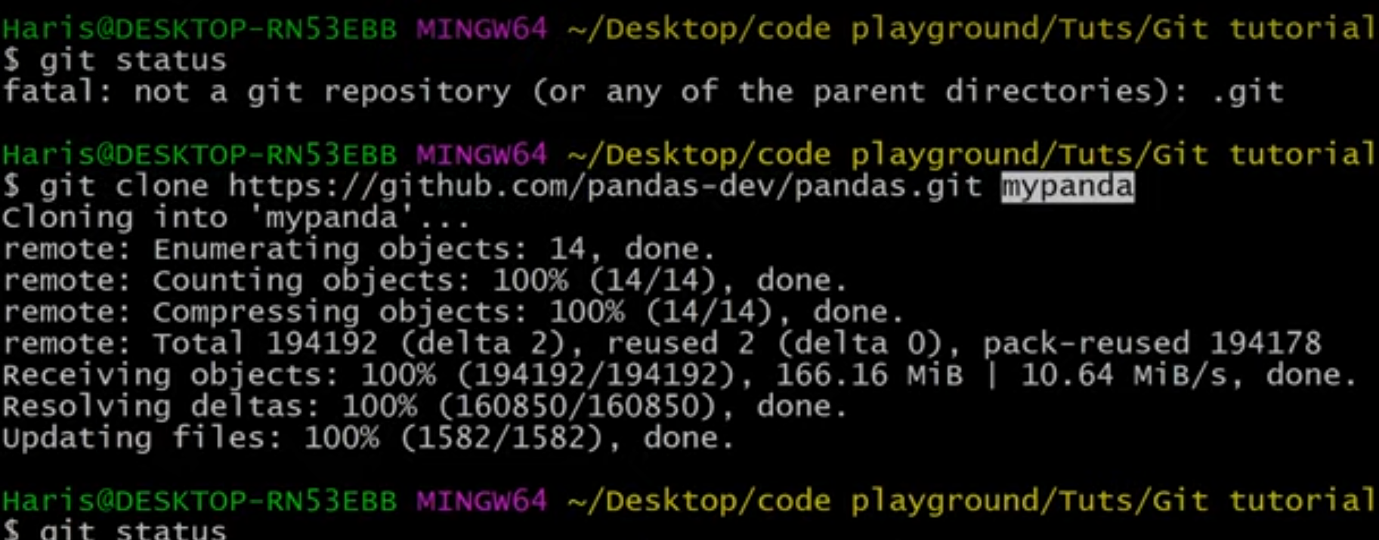

Unchanging and unstaging and last commit option:

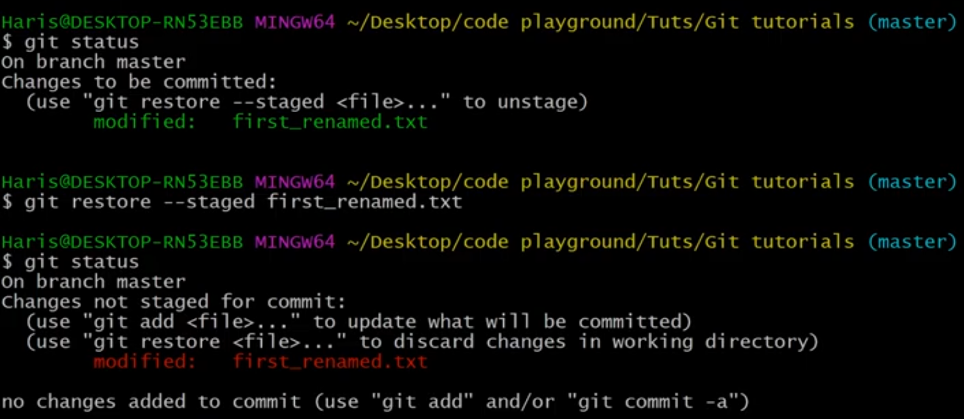

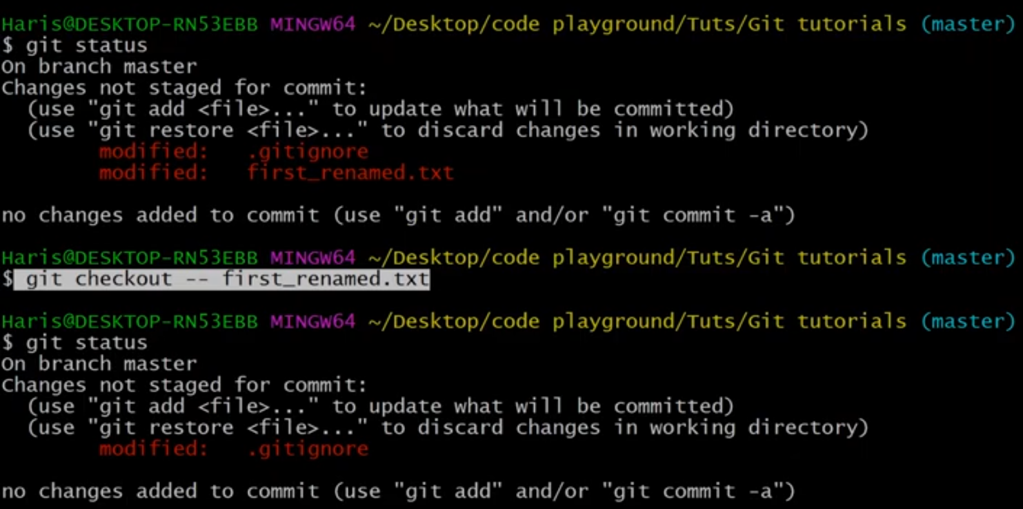

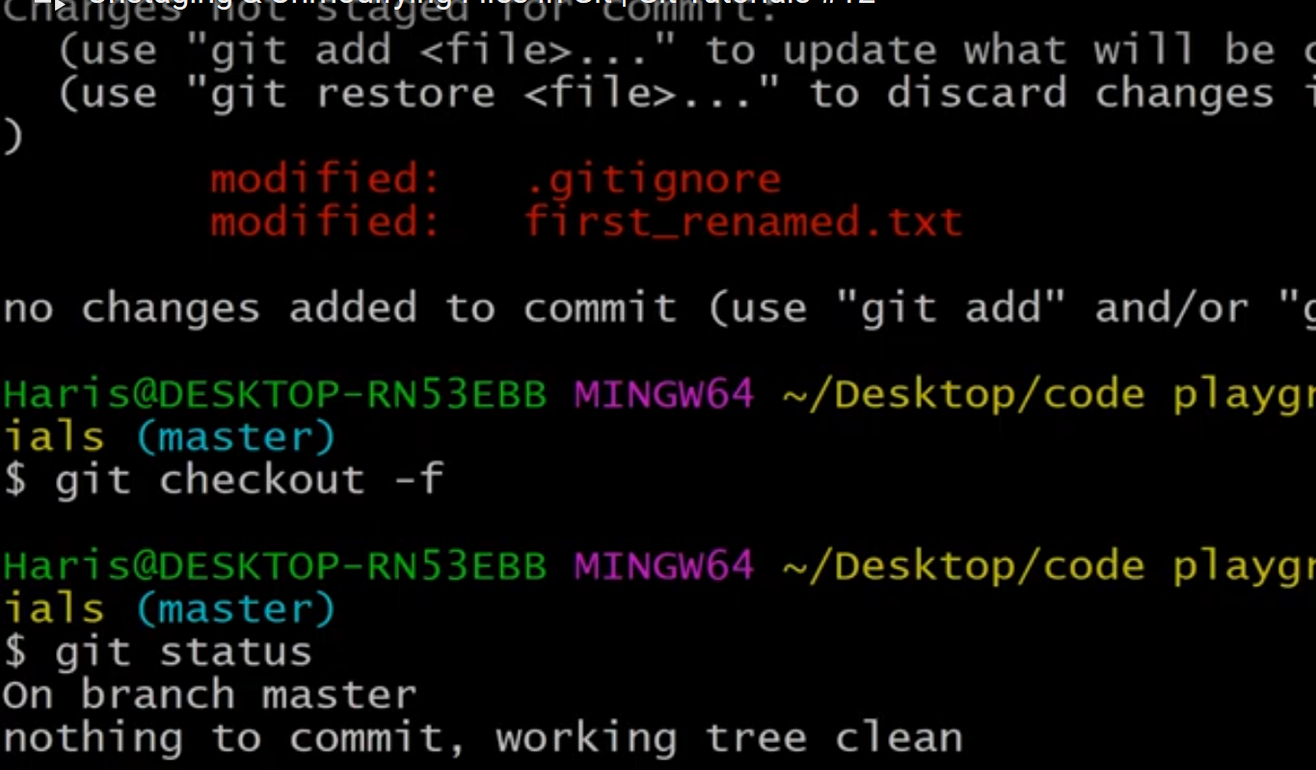

Remotely using git with github or any other platform

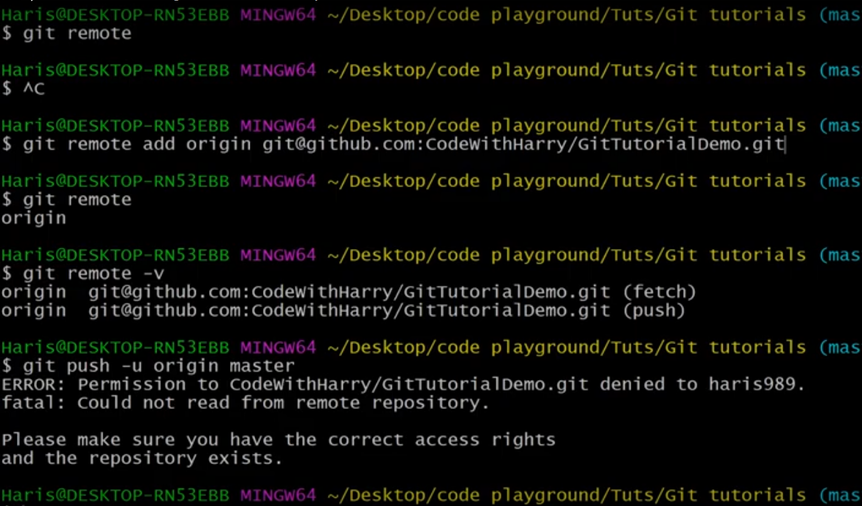

Branching and merging

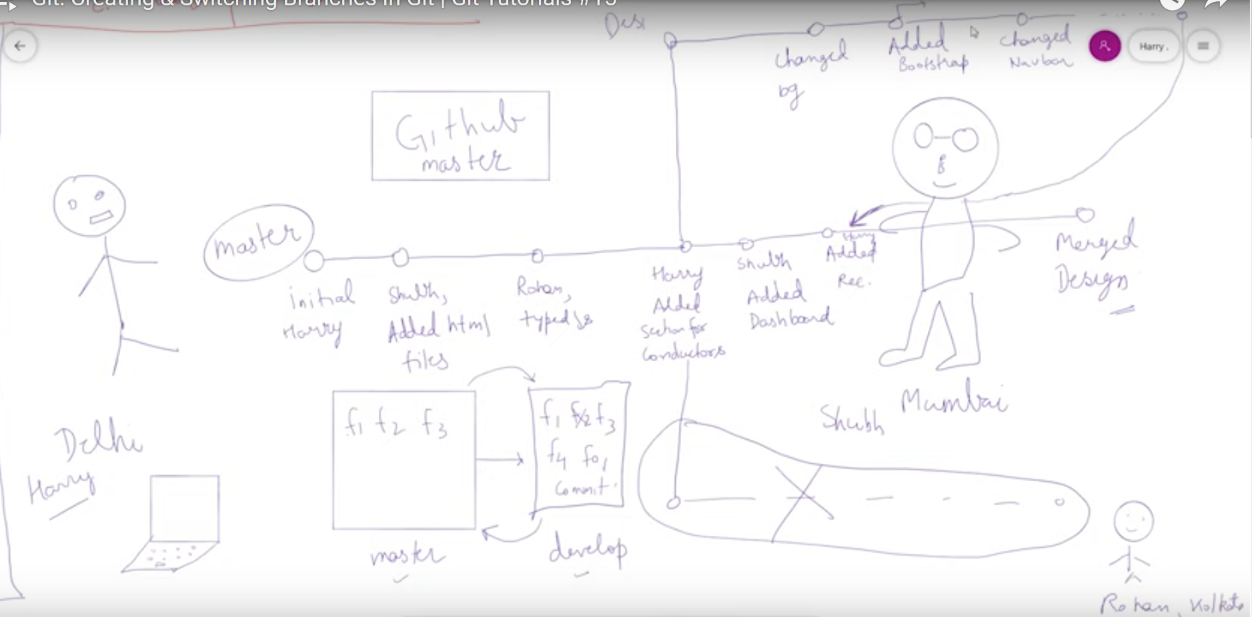

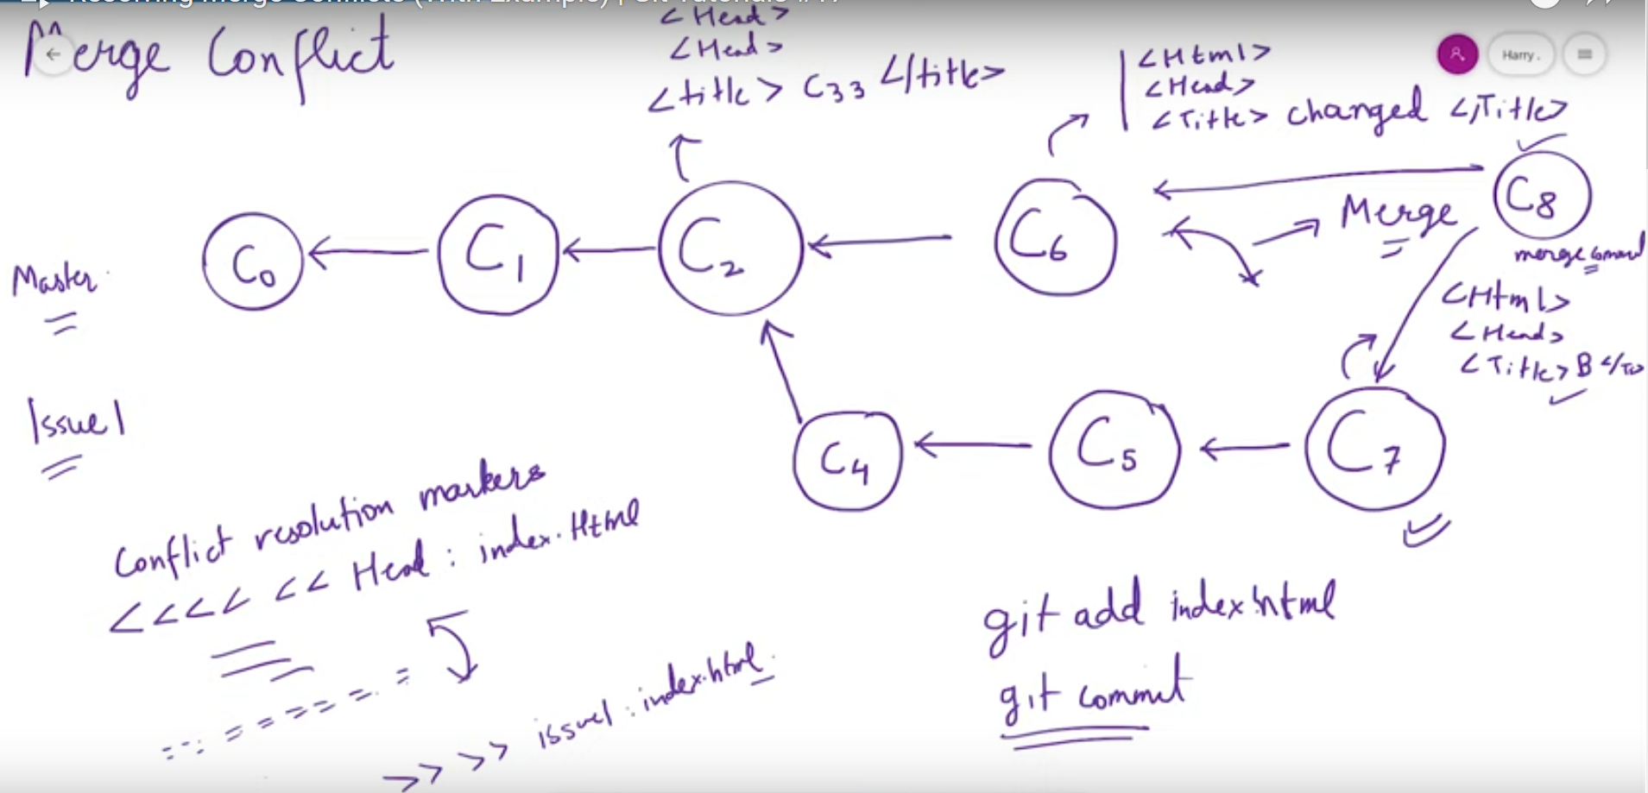

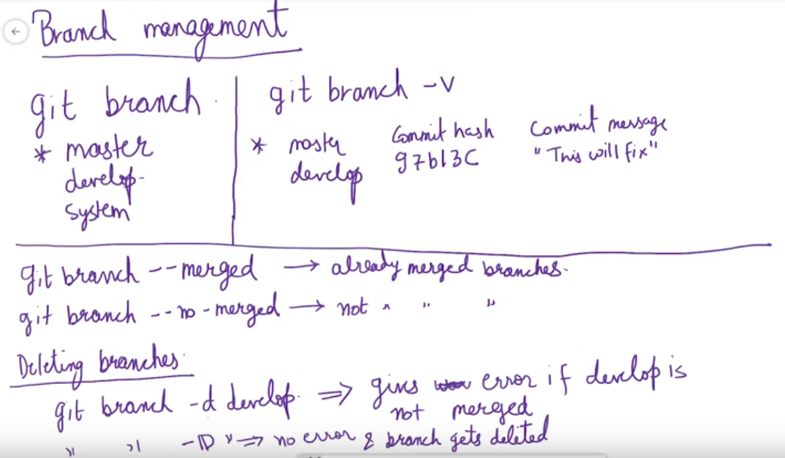

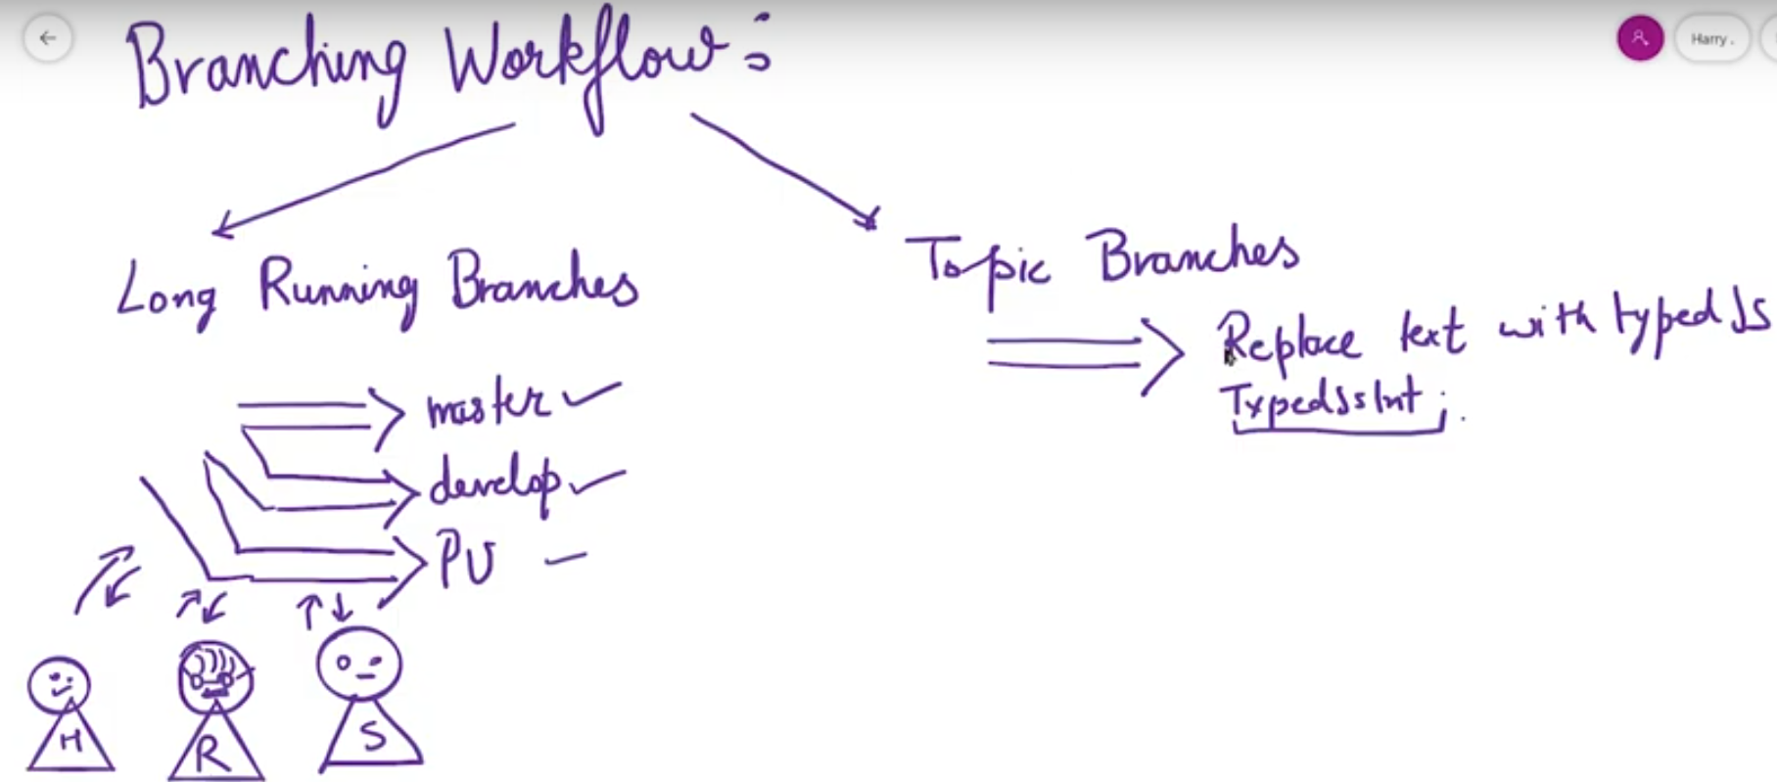

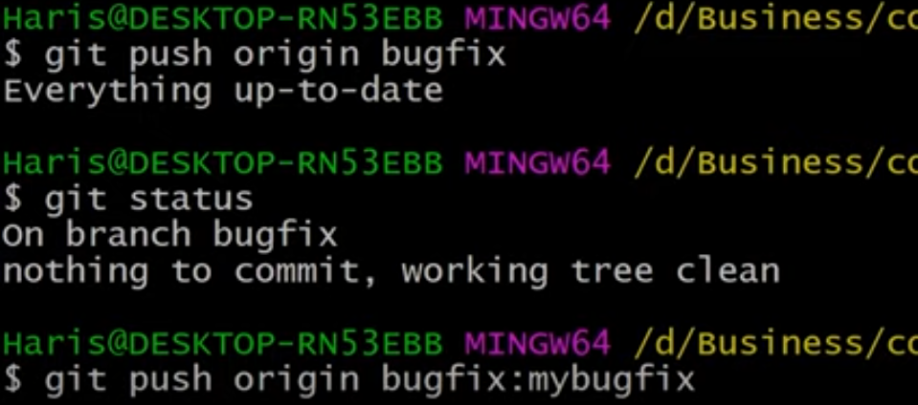

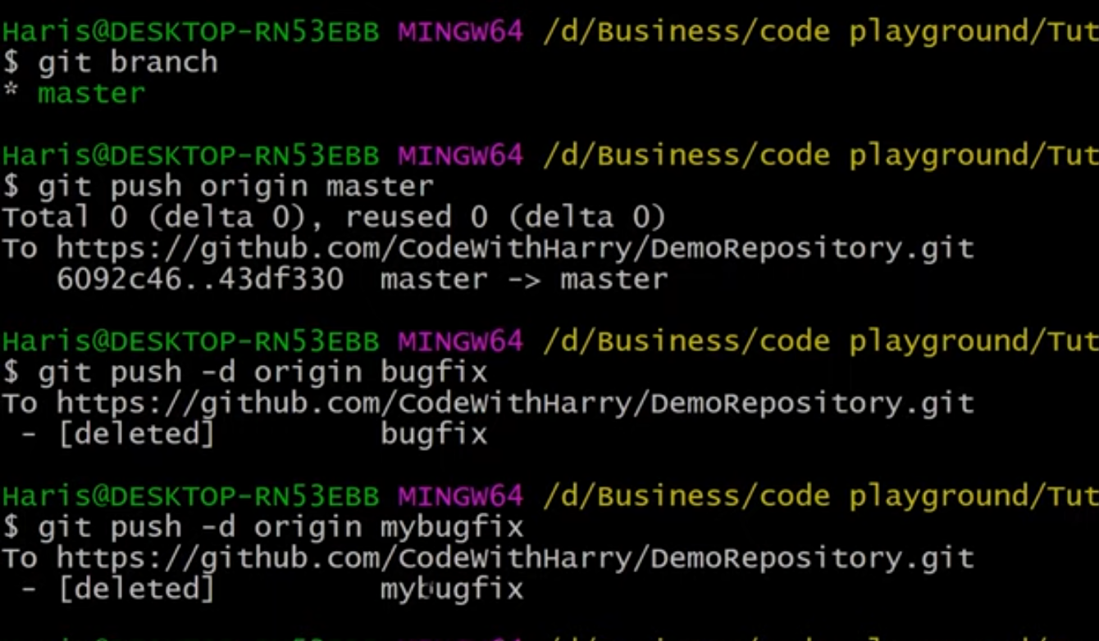

COMMANDS

* git status
* git init
* git add –a
* git add .
* git add filename
* git commit -m “name of commit”
* .gitignore file
* git config --global user.name “name”
* git config --global user.email “email”
* git log
* rm -rf .git
* cd directory
* git diff
* git diff --staged
* git rm “filename”
* git commit -a -m “name of commit”
* git mv filename1 filename2
* git rm --cached filename (removes file and adds into untracked section back)
* git log -p
* git log -p -number (here number means how much commits we want to view)
* git log --stat
* git log --pretty=oneline
* git log --pretty=short (author, message)
* git log --pretty=full (author, commit, message)
* git log --since=2.days
* git log --since=2.weeks
* git log --since=2.months
* git log --pretty=format: “any format” (example “%H -- %an”) (refer git documentations for more)
* git commit --amend
* git clone link foldername
* git checkout -- filename or git restore filename
* git restore --staged filename
* git checkout -f (to go back to last commit)
* git config --global alias.newname ‘full command’
* git checkout -b “name of branch”
* git checkout master (to go back to the branch)
* git checkout branchname
* git merge branchname